Product Roadmapping
Course Project
Instructions
For this project, which builds upon the product strategy and vision, you will create a compelling roadmap that summarizes what you plan to build and when. A roadmap helps you articulate your plan to your team and stakeholders and is a key artifact that you will update regularly.
In Part One, you define your framework by identifying factors to take under consideration.
In Part Two, you create a single repository for storing and organizing potential projects.
In Part Three, you prioritize the projects that will go in your roadmap and determine the sequencing and allocation
of effort.
Except as indicated, use this document to record all your project work and responses to any questions. At a minimum, you will need to provide your instructor with a digital copy of this document as part of your project completion. You may also have additional supporting documents that you will need to submit. Your instructor will provide feedback to help you work through your findings.
Note: Though your work will only be seen by those grading the course and will not be used or shared outside the course, you should take care to obscure any information you feel might be of a sensitive or confidential nature.
Complete each project part as you progress through the course. Wait to submit the project until all parts are complete. Begin your course project by completing Part One below. Directions to submit your work can be found on the final Course Project page. Information about the grading rubric is available on any of the course project assignment pages online. Do not hesitate to contact your instructor if you have any questions about the project.

PART ONE
Define Your Framework
___________________________________________________________________
In this part of the course project, you will tie together your high-level product vision and strategy to lower-level details by defining the factors that will help you prioritize your projects.
Instructions
- Reflect on your product plans and the teaching in this module, and create a list of factors to take into consideration. Consider generic factors along with others that are company- or industry-specific. Some factors may include:
- Engineering effort
- Cost
- Risk incurred by not doing the project
- Impact on each of your objectives (separate factor per objective)
- International considerations
- Regulatory issues
- Any other factors you have identified.
- Using the space next to each factor, provide a 1-3 sentence explanation about why this factor is relevant.

1 | Impact on Mission | “Know me” is a rule by which we provide consumer-centered health care. Evaluation of how this effort aligns and supports the mission of providing personalized health care.
2 | Regulatory Compliance | Ensure that each feature complies with health care regulations and data privacy laws (HIPPA). Compliance is critical to avoid possible data breach and legal issues. We need to know the guidelines for gathering patient information and recognize when it becomes excessive.
3 | Competitive Advantage | Assessing how features differentiate ourselves from other options in the market. Offering unique and tailored experiences will helps us provide a stable position in the market.
4 | Integration with other Systems | Evaluation of integration with the existing EMR system and other third-party technologies (i.e., Authentication)
5 | Scalability | Assessing how we could support a growing user base without compromising performance. Ensure the app can handle increased usage and accommodate growing numbers of patient data.
6 | Time to Market | Evaluation of the time required to launch the feature which has the potential to push back or pause other initiatives.
7 | Engineering Effort | Evaluation of the complexity and time required for the team to develop the feature. Leveraging existing patient data might be less complex vs building mechanisms that can capture new data entered by patients or leveraging AI-driven predictive models.

PART TWO
Source Your Ideas
___________________________________________________________________
In this part of the course project, you will source ideas and create a single repository for storing and organizing potential projects. You will then rate the projects based on the impact they will have across the various factors. This will enable you to prioritize and decide which projects to work on. You can leverage a project management tool, such as JIRA, for this process. However, using a spreadsheet is fine at this stage and can save you time and energy.

Instructions
- Create a spreadsheet using your preferred spreadsheet tool. Any tool with standard features will suffice. Model your spreadsheet after the example in the course.
  - Create a column for each factor, based on your output from part 1.
  - Create a row for each potential project. In the real world, you will be sourcing these ideas from many places, including your team, stakeholders, and maybe even customers. But for this exercise, you will enter them yourself.
  - For each project, rate its potential impact across every factor. For numerical factors, such as cost, provide rough estimations. Write “n/a” if the project will have no impact on a specific factor.
  - A factor that you should almost always include is engineering effort. Some teams will estimate this by roughly “t-shirt sizing” projects as small, medium, or large. Other teams will calculate eng-weeks or engineering-weeks (# of engineers required * number of weeks required). For example, if it would take 2 engineers 10 weeks, the project would be 20 eng-weeks. There are other methods as well. Use whatever works best for your team as long as you are not trying to be too precise. Precision is overrated at this point because it is destined to be inaccurate anyway.

- Save your spreadsheet. You will use it to complete the third part of the course project, and will submit it with your project in Part Three.

Repository for Storing and Organizing Potential Projects
Projects | Factor 1  e.g. Engineering effort | Factor 2  e.g. Increase free to paid user conversion rate | Factor 3 | Factor 4
e.g. Build a wizard  that walks free  users through  premium features | e.g. Medium | e.g. We believe this could have a significant impact on conversion rate, perhaps 10% (this may be a complete guess, but determining whether or not it *could* have a significant impact is critical) | ... | ...
Project B | ... | ... | ... | ...

PART THREE
Create a Visual Roadmap
___________________________________________________________________
In this part of the course project, you will create a visual roadmap that articulates your prioritization decisions in a format that is easy for stakeholders to read and understand.
- Refer to your single repository for storing and organizing potential project. Which factors will hold the most weight in your decision?
  - Decide which factors will hold the most weight in your decision.
  - Based on your factors, your weighting for the most important factors, and your estimations of which projects will have the most impact on each factor, rank the projects in order of priority from 1 to n (where n is the number of projects). If it works better for you, you can simplify and organize them into 3 categories: “now,” “soon,” and “later.”
- Create a visual that shows the sequencing of your projects. You can use a variety of tools for this, including presentation software (Google Slides, Microsoft PowerPoint), spreadsheet software (Google Sheets, Microsoft Excel), a document (Google Slides, Microsoft Word, etc.), or a specialized roadmapping tool. A simple table in a spreadsheet or document is recommended. (See the example in the course.)
  - Create a column for each of the next 4 upcoming quarters (you can start with Q1 or adjust according to today’s calendar).
  - Create categories for your projects. For example, if your projects are roughly aligned to growth, engagement, and monetization, then showing a category for each of those can make your roadmap easier to understand. If your projects tend to impact several objectives, then organizing by objective may not make sense. You could use a totally different categorization, such as front-end improvements, back-end improvements, and third-party integrations. Use whatever you believe helps your readers understand your strategy. If you have a small number of projects or find that adding categories increases complexity, then you can skip the categories and just list projects.
  - Create a bar for each project, joining cells across the quarters where that project will be active. Some projects will be short and others will be long. You can adjust the timeline across the top to be a shorter window (such as weeks or months) if that is more appropriate for the stage of your product. But typically, months or quarters will work well.
- Create a visual that shows your approximate allocation of effort across different categories of investments. Refer to the pie chart example in the Tool: Visual Roadmap Example.
- Choose a time frame, either the next quarter, next 2 quarters, or next 4 quarters. Then, approximate very roughly over that time period what percentage of your engineering team’s effort will go into each category.
- Plot that on a pie chart using your tool of choice.
- If you used categories in your roadmap, use the same categories here. If you didn’t use categories in your roadmap, then either select appropriate categories or simply list every project in the pie chart. (Avoid this if you have more than 10 projects.)

Insert your visuals in the box below:
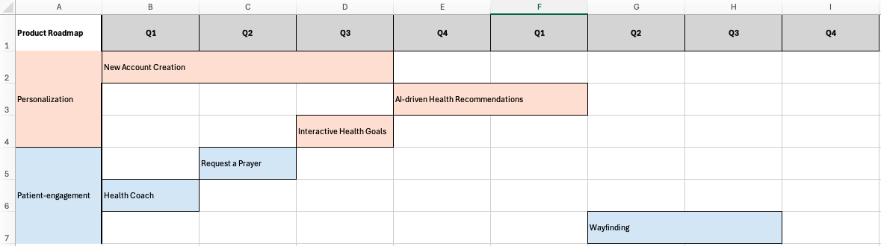

- Using the space below, write one to two paragraphs describing your reasoning and why your roadmap and pie chart look like they do.
  - This is a great opportunity to succinctly summarize the factors you used, the tradeoffs you had to make, and why you think this is the right strategy.
  - A key product management skill is communicating clearly and succinctly. This should be short. Less is more.
  - This final output, with the roadmap, the pie chart, and the description, will give you a summary of all the work you have done so far and an artifact that you can easily share with people throughout the company.

I divided the roadmap into Personalization and Patient-engagement categories. The top priority is New Account Creation due to its significant impact on consumers and alignment with our mission pillars—“know me” and “love me”. I also prioritized quick wins alongside longer projects to show progress to stakeholders and continuously meet consumer expectations.

________________________________
To submit this assignment, please refer to the instructions in the course. Be sure to submit your Part Two spreadsheet with this project document.

